**Running a Powershell Script from Task Manager:**

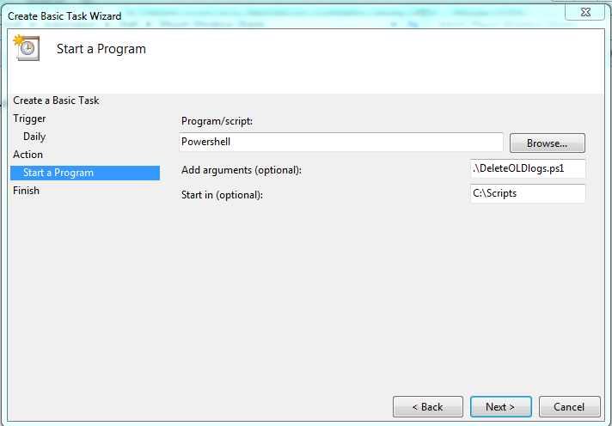

**Name:**

**DELETE_OLD_LOGS**

**Program/script:**

Powershell

*#Add the below as an argument to bypass the execution policy set by default by windows:*

**Add argument (optional):**

-ExecutionPolicy Unrestricted c:\Scripts\DeleteOLDlogs.ps1

**Start in (Optional):**